**Specimen Testing Station**

**Personal Protective Equipment**

* Medical Mask
* Eye Protection
* Gown
* Gloves

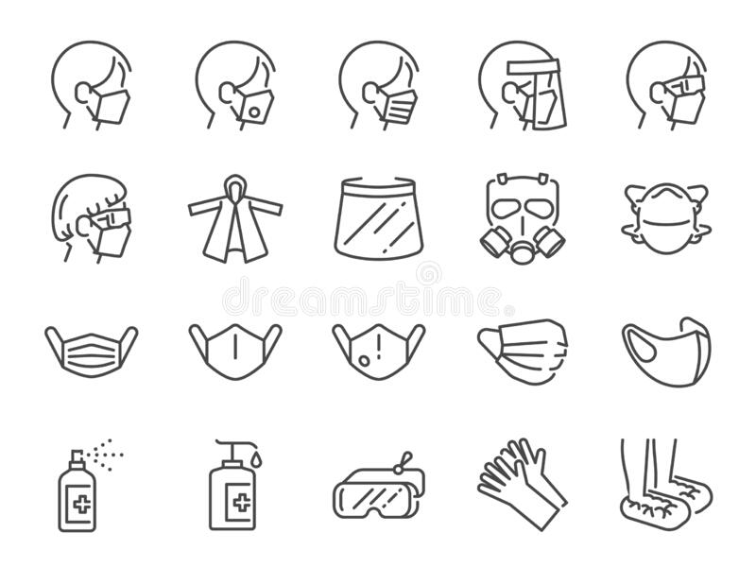

**Role Description**

This person will:

* Receive plastic transport container from participant
* Direct participant to waiting area or to the exit
* Prepare test device cartridge with label and specimen
* Set 15 min timer
* Interpret results
* Communicate results
* Document results
* Perform quality control checks

**Cleaning & Disinfecting**

Beginning and end of day:

* Work table
* Plexiglass screens
* Laptop (with alcohol swabs)

After each participant:

* Plastic transport container
* Any surfaces touched

**Communication**

Negative Results:

* Notify participant by preferred method
* Counsel to still follow IPAC measures

Preliminary Positive Results:

* Notify participant directly (in person/phone)
* Advise to self-isolate and book COVID-19 test at regional testing centre within 24 hours
* Notify Rapid Testing Lead as soon as possible

**Quality Control Swabs Should Be Tested:**

* With any new kit lot number
* Daily: for sites performing more than 25 tests/day
* Weekly/each time new box is opened: for sites performing less than 25 tests/day

**Documentation**

* Use the provided spreadsheet to track all results.
* Be sure to document under the correct week and date.
* Track quality control on this spreadsheet on the yellow tab.