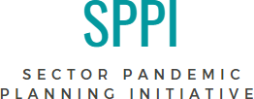

PANDEMIC PLAN FRAMEWORK

COVID-19 Risk Assessment Tool

Author- Hamilton Developmental Services Sector Committee in Consultation with Hamilton Public Health
Legal Content Review and Input- Brendon Pooran, PooranLaw
Version 1.0- October 2020

Content
Guidelines for Use 2
Determining Risk Impact 3-4
Legal Considerations 5-6

RISK ASSESSMENT TOOL – Guidelines for Use
Developed by the Hamilton Developmental Services Sector Committee in Consultation with Hamilton Public Health

What is the purpose of the Risk Assessment Tool?
- To assess the level of risk of persons supported participating in community activities.
- To identify strategies to mitigate the risk of participating in these activities.
- To determine the overall level of risk associated with the activity and/or setting.
- To assist with the decision to permit a person supported to engage in a specific activity or attend a setting outside of their living arrangement.

Caution: It is important to note that while risk mitigation strategies can reduce the risk of COVID-19 infections, they cannot completely eliminate the threat. It should also be noted that risk assessment is a cyclical process. Documenting and reporting on the findings of the risk assessment; communicating key messages to participants and staff and monitoring and reviewing the risk assessment must continuously occur and be updated to account for changing circumstances and information. It is important to note that the tool provides guidelines only and is not a definitive decision-making tool to be used in isolation of public health information and guidelines.

When to use the tool:

The Risk Assessment Tool is intended to assess the level of risk associated with persons supported participating in activities in the community, i.e. returning to work/volunteering positions, participating in specific community outings, before introducing new activities or before introducing changes to existing activities. The tool can be used to prepare for and mitigate the risk of participating in approved activities during emergency orders.
This risk assessment tool will also help to determine next steps, the risks vs. benefits, where restrictions can be lessened, where the level of risk can be reduced and the prioritization of risks. It will also assist with exploring how imposing safeguards such as additional staff, considering lower risk activities and off-peak hours may reduce the level of risk associated with the activity and/or setting. Refer to Table 3 for examples of activities and varies risk levels.
USE
There are three pillars to the Risk Assessment Tool:

- Risk Assessment
- Risk Mitigation Checklist
- Overall Risk Score

The tool should be completed in the Excel spreadsheet as the scores are automatically calculated. The matrix will assist in determining the overall risk of contributing to COVID-19 community transmission and next steps.

Step 1: Complete the risk mitigation table (Tab 1 of risk assessment)
Step 2: Complete risk assessment to assess overall risk (Tab 2 of risk assessment)
Step 3: Determine overall risk score by assessing (Tab 3 of risk assessment)
Step 4: Refer to the risk assessment matrix to determine the risk mitigation potential (Table 1)
Step 4: Refer to the risk assessment flow chart to determine overall level of risk (Table 2)

Determining Risk Impact

Organizations need to determine their threshold and acceptable level of risk under the current phase of the emergency orders. For example, an organization may determine that under Phase 3, activities that fall within the Low-Moderate risk level are acceptable. If the risk is deemed acceptable, the activities can proceed without additional mitigation measures. If the risk is deemed too high, risk mitigation strategies must be developed and implemented. The level of approval needed should be determined by the organization based on the overall level of risk. Example, overall low risk requires Supervisor approval; overall medium risk requires a Managers approval, etc.

Table 1 Risk Assessment Matrix

The risk assessment matrix is used to determine the risk mitigation potential by assessing the level of risk as Low, Medium or High and the consequence result as Weak, Moderate, or Strong

The total Mitigation Score (%) from the mitigation table is used to determine the risk mitigation potential
Stronger  (75-100%) | Moderate  (25-75%) | Weaker  (0-25%)
The total COVID-19 Risk Score from risk assessment tab is used to determine the risk level
High  (27 or greater) | Medium  (20-26) | Low  (1-19)

Table 2 Risk Assessment Flow Chart

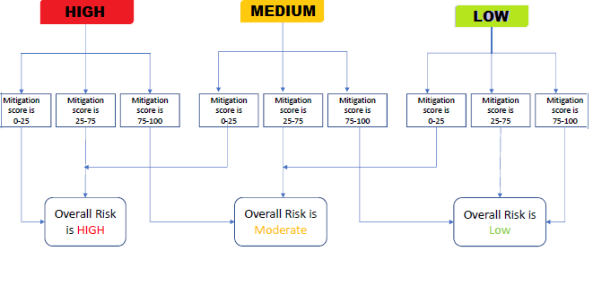
*This tool was developed with reference to the Government of Canada COVID-19 Guidance Documents and the World Health Organization COVID-19 Risk Assessment Tool – Generic Events

Table 3 Government of Canada’s Guide for Going out Safely
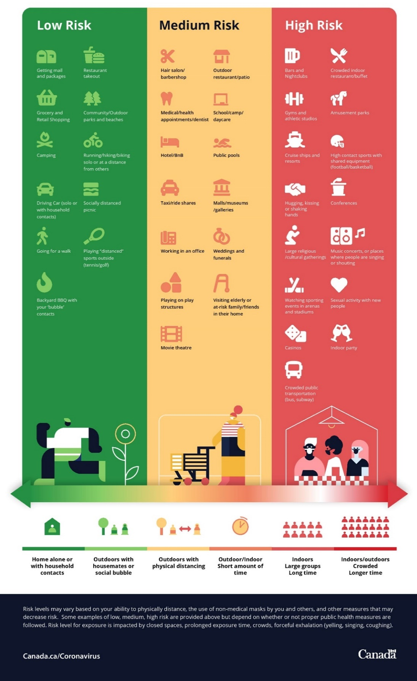

Legal Considerations:
The Risk Assessment Tool should be used in accordance with current legislation, regulations, ministerial directives and public health guidance related to COVID-19. Note that Ontario is currently in a declared state of emergency under section 7.0.1 of the Emergency Management and Civil Protection Act (the “EMCPA”) which provides the provincial government additional powers to determine what can and cannot be open in the province and greater enforcement powers. Under the EMCPA there is also a Stay-at-Home Order in effect until at least February 9, 2021. As a result of these orders, there are significant limits to what businesses are open and activities/programs can continue to operate at this time, and any community activity should be considered ‘high risk.’

The Risk Assessment Tool will be applicable once the province transitions back to reopening.

Reopening Framework

In July 2020, the province enacted the Reopening Ontario Act (the “ROA”) which established a framework to classify individual regions in colour-coded stages based on the risk level of that region:
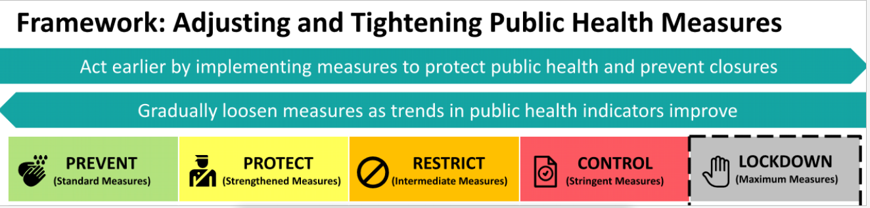

Areas deemed in the “grey” lockdown zone are considered to be high risk and in “Stage 1” of reopening. At this stage there are maximum limits on which businesses/service providers can remain open, limits on capacity, and the mandating of individual requirements such as physical distancing, wearing a face mask/covering (with exceptions) when attending at a business or receiving a service.

Areas deemed in the “red” zone are considered to be in “Stage 2” of reopening and are still under stringent limits but more businesses/service providers are permitted to be open. There is still a significant risk to community outings and gatherings.

Areas in the “orange” “yellow and “green” zones are considered to be in “Stage 3” of reopening. Measures are more relaxed and there is lower risk of transmission, more business/service providers that are permitted to open and an overall lower risk associated with community outings.

It is important to assess the risks of outings and activities both in terms of the nature of the outing and/or activity but also where the outing and/or activity is taking place. The regulations for reopening, as amended from time to time, should guide the application of the Risk Assessment Tool. Note that the legislated reopening framework is not determinative of risk for Developmental Services (“DS”) sector agencies and the people they support.

In addition to the parameters set out in the legislation with respect to reopening, when assessing risk, DS sector agencies should consider their legal obligations and authority under O. Reg. 177/20: Congregate Care Settings and O-Reg 121/20 Service Agencies Providing Services and Supports to Adults with Developmental Disabilities and Service Providers Providing Intervenor Services, including the obligation to comply with public health guidance and the single employer rule.

The Risk Assessment Tool should also be used in conjunction with the following laws and guidelines:

- O.Reg 299/10 Quality Assurance Measures – in particular, balancing obligations under section 4 to promote social inclusion, individual choice, independence and rights, section 7(1) to develop policies and procedures with respect to “health promotion, medical services and medication” and section 12(1)(a) to develop policies and procedures that protect the personal safety.

- Occupational Health and Safety Act – in particular, section 25(2)(h) imposing a general obligation on employers to take all reasonable precautions to make a workplace healthy and safe. DS Sector agencies should also be mindful of a worker’s right to refuse work if they believe it is dangerous to their health and/or safety.

- Ontario Public Health COVID-19 Preparedness and Prevention in Congregate Living Settings - outlines infection prevention and outbreak management steps that can be implemented in congregate care settings related to cleaning, masking and other personal protective equipment, masking and face coverings, safety planning and communication strategies.

- Congregate Care Setting Public Health Guidance - Ministry of Health and Long-term Care guidance with which DS sector agencies are legally obligated to comply. The guidance outlines public health measures that DS sector agencies should be taking with respect to planning and training on COVID-19 safety precautions and preventing COVID-19 transition.

- Ministry of Children, Community & Social Services (“MCCSS”) Interim Direction in Congregate Care Settings - applies to people supported in congregate care settings relating to limitations on visits (inside and outside) and short stays and absences. The Direction sets out a clear expectation that people supported remain at home and outlines “enhanced precautions” for people supported when returning from visits (i.e. isolation/limited contact, screening, symptom monitoring, hand washing etc.).

- MCCSS COVID-19 related memos to DS sector agencies - received by DS Sector agencies in relation to COVID-19 measures and policy development specific to the sector.

O. Reg. 363/20: Stages of Reopening.
O. Reg. 82/20: Rules for Areas in Stage 1.
O. Reg. 263/20: Rules for Areas in Stage 2.
O. Reg. 364/20: Rules for Areas in Stage 3.
RSO 1990 c O.1

